**Chapter 1**

**Introduction**

**1.1 Project Context**

"Examination is a formal test of a person's knowledge or proficiency in a particular subject or skill" (Jolanta Lapiak Handspeak, 2010). Test plays an important role as it provides benefits between the instructor and the student. The instructor can assess the students through an exam and give direct assessment and students can achieve self-assessment for them to monitor their studies.

Through interview conducted by the proponents with the dean, instructors and program heads in different department, the p­­­­­­­roponents found out that AMA Computer Learning Center is still using the manual method in creating test questionnaires. There are problems found in using this method in creating, submitting, checking and approving of test questionnaire and table of specification such as no storing of test questions, it consumes more papers in revising the test questionnaire and table of specification during checking. Instru­­ctors will create first the syllabus that contains the topics for the whole semester are utilized as guidelines. Creating test questionnaires based on the table of specification that follows the Bloom's taxonomy aligned to the topics indicated in the syllabus of the

2

instructor. The program head and dean for the specific department will now check the created test questionnaire and table of specification of the instructor if the questions conform to the appropriate cognitive level domain requirements.

The proponents came up with the idea in proposing a test banking system. The test banking system will enable the instructor to create syllabi, test questionnaire and table of specification as well as retrieve test questions and test questionnaire depending on the subject they are teaching.

The program head can check, approve, reject and put remarks on the test questionnaire that the instructor created. The dean can double check the test questionnaire, reject and approve test questionnaire for printing. The system can queue the test questionnaire to be printed with copy of each test questionnaire. Test banking generates reports such as approved, rejected, printed, pending and late test questionnaire and table of specification list, also offers systems notification, chatting and SMS notification for additional features. By this, it can improve the way of creating, passing, checking, printing, retrieving and storing of test questionnaires.

3

**1.2 Purpose and Description**

The main purpose of this study is to create a storage for the test questionnaires for retrieval purposes in order to reduce the use of papers when creating and revising test questionnaires.

The beneficiaries of this project, are first, the instructors. It will help the instructors to create test questionnaires and table of specifications in a more convenient way, wherein test questionnaires and table of specifications are created in the system and lessens the usage of paper upon creating and revising test questionnaires. The instructors can get additional references in the test bank when creating new test questionnaire and also provide reports for the progress of the created test questionnaire.

Second, the program heads. It will help the program heads in checking test questionnaires according to the chronological sequence. Placing remarks also in the provided slots in the system, approving and rejecting test questionnaires and table of specifications is also embedded. The program head can receive reports of the submitted test questionnaires.

Third, department deans. It will help the dean check, reject for revision and approve for printing of the test questionnaires and table of specifications. A report helps the dean to manage the status of the instructor whether passed late, approved or pending.

4

And lastly, the school, It can lessen the cost of the usage of papers for test construction.

**1.3 Objectives of the Study**

The main objective of the proposed project is to provide and develop a Test Banking System process that is based on the cognitive levels defines by Bloom's taxonomy.

Specifically:

1.) Gather data and information from the user for the user requirements of the system;

2.) Create a code for the ACLC Test Banking System;

3.) Test the usability, reliability and effectiveness of Test Banking system to the instructors, program heads, department Deans and printing in-charge of ACLC College of Butuan;

4.) Create security measurements for the system to be secured; it includes integrity, availability, confidentiality, accountability, and assurance of ACLC Test Bank System.

**5**

**1.4 Scope and Limitation**

**1.4.1 Scope**

Test banking system provides storage for all test questions according to the cognitive levels of Bloom's taxonomy that have already been approved by the dean. It lets the instructor create and retrieve test questions and test questionnaires, can give instructor automatically generated table of specification based on their test questionnaire created, can print test questionnaires and table of specifications for the purpose of having a hard copy and can submit test questionnaires and table of specifications to the program heads. The program heads can view, check and place remarks on the submitted test questionnaires and table of specifications of the instructors. They can also approve the test questionnaires and table of specifications which will be forwarded to the dean or otherwise will reject the test questionnaires and table of specifications and send it back to the instructor for revision. The dean can set the date of submission of test questionnaire and table of specification, and also add additional remarks, reject and approve test questionnaires and table of specifications for printing. Test banking system can queue test questionnaires to be printed with a default copy of each. It also provides reports depending on the coverage task of specific user.

6

In addition, it offers short text message notification for updates to the entire faculty and system messaging for the deans, program heads, and instructors in different departments of ACLC College of Butuan.

**1.4.2 Limitation**

The proposed system is limited in the automatically sorting of test questions based on the cognitive levels of Bloom's taxonomy. It can't manipulate the queuing number of test questionnaires to be printed by the printing in charge. Also, it cannot scan image to be uploaded into the system. The system is not accessible by the user outside the school premise. The system can't be accessible when experiencing power failure or network problem

7

1.5 Definition of Terms

**Syllabus -** an outline of the subjects in a course of study and teaching.

**Test bank**- is a ready-made electronic testing source that can be customized by the lecturers for their teaching

**Table of specification**- It is a two chart which describes the topic to be covered by a test and the number of items or points which will be associated with each topic.

**Test questionnaire** - It is an instrument consisting of a series of questions and other prompts to gather information and assessments.

**Bloom's taxonomy** - is a classification system used to define and distinguish different levels of human cognition; thinking, learning, and understanding

**Store** - the action or method of storing something for future use.

**Chapter 2**

**Review of Related Systems**

**2.1 Related Systems**

**ACLC Test Bank**

The previous study of the Test Bank System by Kara P., Felix T., Cyrell N., and Madel C., 2015 which we attempt to replicate and enhance the capabilities of the system such as the storing of test questionnaires, organizing them to the type of questions (e.g. multiple choice, enumeration, essay, etc.) as well as organizing the questions based on its cognitive level in the bloom's taxonomy cognitive domain. Their system can also retrieve approved questions and/or questionnaires that are saved in the database for printing. Also the users in their system can access, retrieve, and print the stored test questionnaire depending on course and topic. Their system can also scan previously used test questionnaire and store them in the database.

9

**Table of Specification (Bloom's Taxonomy)**

This is the basis of the instructors for making the test questionnaires. After making the test questionnaires, they make sure that the questions are well distributed in the cognitive levels: 30% which comprises of knowledge, comprehension, application and 70% which comprises of analysis, evaluation and synthesis.

**Bloom's Taxonomy Cognitive Domain**

According to the proponents' research, Bloom's taxonomy is a set of three hierarchical models used to classify learning. There are six levels in the cognitive domain of Bloom's taxonomy: knowledge, comprehension, application, analysis, synthesis and evaluation. These six types are used in creation of questions: knowledge being the first level in the bloom's taxonomy and evaluation as the sixth level.

This is the basis whether the students have learned anything in their subjects or not as this will be helpful in measuring the students' capabilities. Overall, the instructors use this as the basis for creating questions for the test questionnaire either using keywords or the structure of the question.

10

**Portable System for Choosing Pre-Operative Patient Test**

This system is an interactive medical test selector used by patients. It can display questions and allows the patients to answer questions by presenting 3 choices for them to answer, yes, no, and not sure. It can only save and store the patient's answer. The proponents researched about this particular existing system as part of the related system because of the proponents proposed system is similar to this existing system in which it candisplay questions and store it in the database.

**Internet Test-making Method**

The existing system which is the internet test-making method is a method that creates tests, assessments, surveys and lesson plans with images, sound files, and posting them online for potential users. Questions are inputted by the test creator, then it is compiled into a test by a host system, after that, it is then posted online for potential test-takers. The compiled test may be stored in a directory and/or database, then the directory is categorized to the corresponding to the different types of tests and it is placed in the appropriate category.

11

**Data Mining**

Data mining, also called Knowledge Discovery in Databases (KDD), is the field of discovering novel and potentially useful information from large amounts of data. It has been applied in a great number of fields, including retail sales, bioinformatics, and counter-terrorism. Data mining tools predict future trends and behaviors, allowing businesses to make proactive, knowledge-driven decisions

**Data mining for a Web-based Educational System**

This system allows educators to study how the students learn and which learning strategies are most effective to use. It investigates data mining methods for extracting useful and interesting knowledge from the large database of students who are using LON-CAPA (Learning Online Network with Computer Assisted Personalized Approach) educational resources since web-based educational systems are capable of collecting vast amount of student's data.

12

**Data Mining Applications in Biometrics System**

Biometrics systems are systems that use physical and behavioral features for granting access to the computing systems and networks. The physical features could be fingerprints, iris, voice, and behavioral features could be gestures, gait and facial expressions. While significant progress has been made on biometrics technologies, there have also been numerous developments in data mining technologies. Data mining techniques such as neural networks are being applied for automatic face detection. Furthermore, data mining techniques are also being applied for security applications such as intrusion detection. There is also now working on applying data mining techniques for detecting intrusions in biometrics systems.

**Chapter 3**

**Design and Methodology**

**3.1 The Project Concepts**

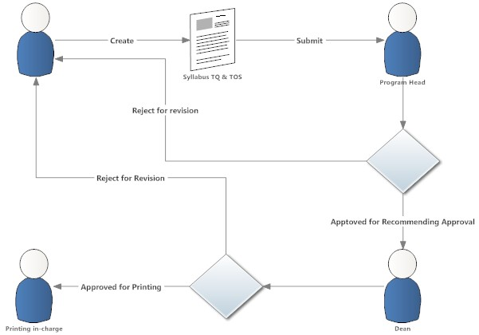

*Figure 1 Conceptual Diagram of Existing System*

The instructors create a test questionnaire and table of specifications, then submits it to the program head for approval. If rejected, it will be sent back to the instructor. If approved, the program head will submit it to the department dean

14

for recommending approval. If the test questionnaire and table of specification are approved by the department dean, then it is ready to be printed. If it is rejected, it will be sent back to the instructor

**3.2 System Analysis and Design**

**3.2.1 System Requirements**

In developing a system, the proponents should consider all the requirements needed such as hardware requirements and software requirements in order to maintain the efficiency and functionality of the system. If the computer system does not meet the system requirements, then the software may not work correctly.

The proposed system's hardware requirements are Hard disk that has 120GB of space, Memory that has 2GB of space and CPU that has 1.90ghz intel Celeron. The proposed system's software requirements are Xampp that is used for the hosting:

Browser to run the system, operating system that is windows 7 or windows 8.

15

Table 1 Hardware Requirements

|  |  |
| --- | --- |
| Specifiation Name | Minimum Requirements |
| Hard Disk | 120Gb or Higher |
| Memory | 2gb RAM or higher |
| CPU | 1.90 gHz Intel Celeron |

Table 2 Software requirements

|  |  |
| --- | --- |
| Name | Minimum Requirements |
| Xampp | This is for all the uses that is required to run the system as this is the package for the database (MySQL) and Apache for Hosting. |
| Browser(Preferably Google Chrome) | This is used to run the system as it is a web-based system. |
| Operating System(Windows 7 or higher) | This is the minimum requirement to run the system. |

16

Table 3 User Requirements

User requirements table consists of: Name of the Project, User, Main Module, and Sub Modules. See appendices E for User Requirements table.

Table 4 Scope Meet Point

Scope Meet Point shows all the scope of module and sub modules that the proponents meet in developing the ACLC Test Bank System. See appendices E for the scope meet point table.

**3.2.2 Functional Requirement**

The system should accept test questions to be able to create, view, store, retrieve and be able to generate table of specification based on the test questionnaire that the instructor created and generate reports to stay updated about the test questionnaire they submitted, checked, validated and historical date purposes. Queuing in submitting, checking and printing test questionnaire and table of specification to make it organize.

17

**3.2.3 Non-functional Requirement**

Test banking should acquire reliability, operability, availability, and maintainability. Reliability to test and measure the data to be processed. Operability on how it prevents system failures. Conducting a training for the users to operate the system and making them part of the system can prevent system failures in way that they will know how to operate the system properly and to make an assurance that the system can operate the intended processes. Availability that provides data to be available in terms of creating and modifying test questionnaires. Lastly, maintainability that provides a full documentation for the system user and the system should be able to maintain its functionality, keeps the data updated and security ensured.

18

**3.3 System Design**

**3.3.1 Development Model**

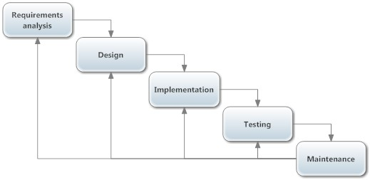

*Figure 2 Phase of System Development Life Cycle*

(Iterative Waterfall)

The proponents used the system development life cycle (SDLC) method. It is a step by step process where the proponents can't proceed to the next step unless the proponents finish the first step. It involves the requirement gathering and analysis, design, implementation, verification, and maintenance.

19

**3.3.1.1 Requirements Analysis Phase**

During the requirement gathering and analysis phase, the proponents plan everything such as gathering data from the instructors, program head and department deans and identify the things needed to do, use and possible outcome of the proposed system. Title will be formulated, scopes, modules and other matters such as timeline for making the proposed project

**3.3.1.2 Design**

After the requirement analysis phase, the proponents developed the design of the project. The system design was based on the module and scope that the proponents constructed.

20

**3.3.1.3 Implementation**

During implementation phase, the system functions will be developed. The syntax and the queries needed to the proposed system will be created and built through the aid of different software is indicated in table 2. Software requirements in chapter 3.2.1in order to make the system functional. But before the proponents will deploy the system it needs to undergo the next step which is the verification phase.

**3.3.1.4 Testing**

The proponents plan to test the usability, reliability, effectiveness and efficiency of the system through functional testing in order to verify the reliability of the system based on the user requirement System usability and validation will be tested using the system usability scale test.

21

**3.3.1.5 Maintenance**

Last phase is the maintenance phase. This phase can be work on after the completion of the project. It is the proponent's responsibility to keep the proposed system functional and working well. The proponents will conduct the maintenance through back up of the stored data from the database. Also, the system should be checked regularly to maintain the functionality and avoid bugs and errors.

**23**

**3.4 Development Approach**

**3.4.1 DFD Level**

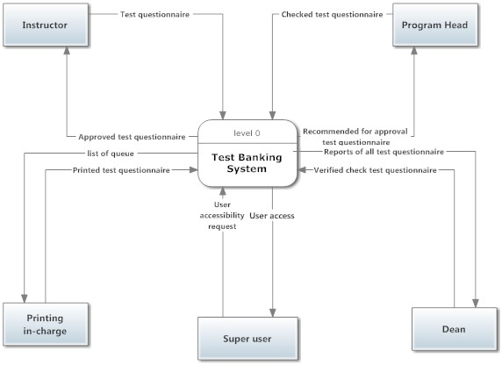

*Figure 3 Context Diagram of Proposed System*

This figure shows that the process is being minimized. Creating, modifying, checking, validating and approving test questionnaire and table of specification are being executed inside the system, and the system can now store and retrieve test question for future use of creating and modifying test questionnaire and table of specification.

24

**3.4.3 Entity Relationship Diagram**

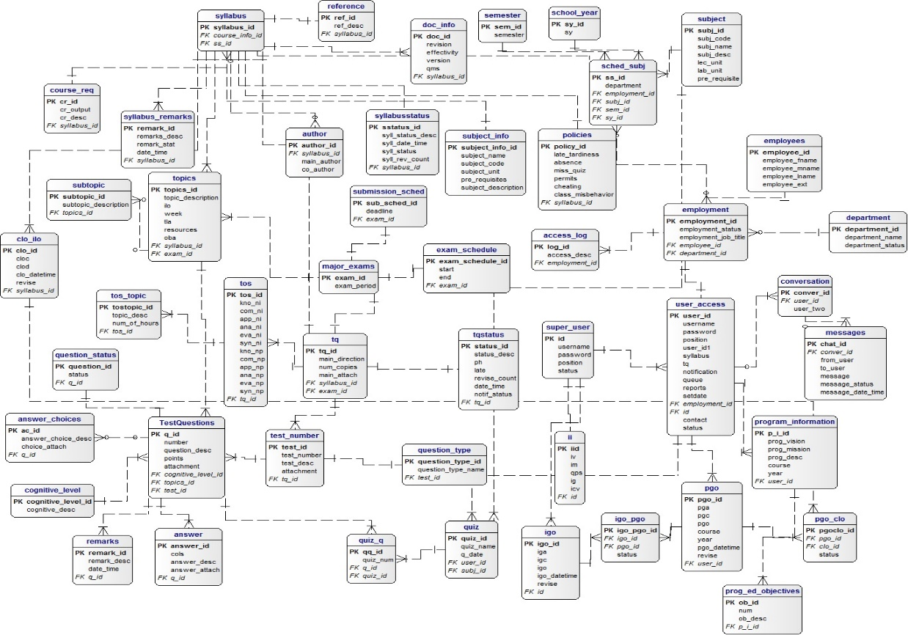

*Figure 5 entity relationship Diagram of ACLC Test Bank*

The figure above shows the process of data. Shows how data are being processed and stored.

**3.5 Software Development Tools**

The Tables show the front-end and the back-end software development tools that were used for the interfaces and functionalities in the system.

Table 5 Front-end

|  |  |
| --- | --- |
| Name | Description |
| Bootstrap | This will be the graphical user interface (GUI). This is to have a more professional approach for the system. |
| Sublime | The proponents will use this as the code editor to create the front-end of the system. |

|  |  |
| --- | --- |
| Name | Description |
| Sublime | The proponents will use this as the code editor to create the back-end of the system. |
| MySQL | The proponents will use this as the storage for data. This will be the database. |
| Apache | The proponents will use this to run PHP Functions |
| PHP: Hypertext Pre-Processor | The proponents will use this scripting language to create the system. |

26

**3.6 Schedule and Timeline**

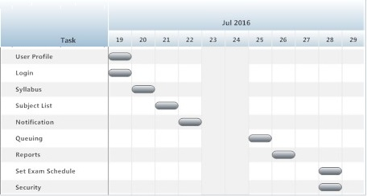

*Figure 6 Graphical User Interface Development Timeline*

The figure shows the development timeline of the Graphical User Interface. This serves as guidelines for the proponents in the Graphical User Interface of the system.

27

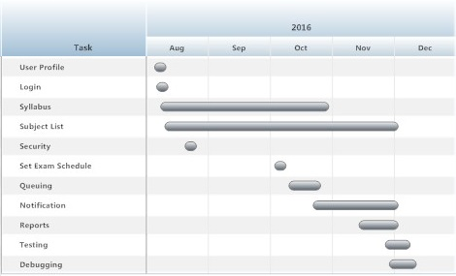

*Figure 7 Functional Development Timeline*

The figure shows the schedule and timeline of the functional development. The proposed project will be fully developed by the proponents following the steps of the iterative waterfall model. This chart will serve as guidelines for the proponents so that the banking system will be deployed and test on the specified time.

28

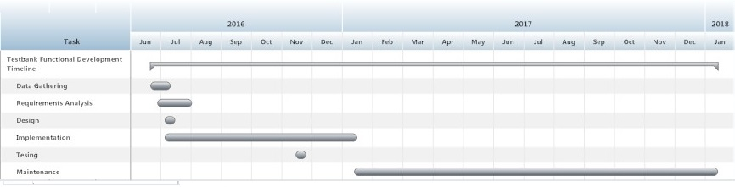

*Figure 8 ACLC Test Bank Project System*

The figure shows the schedule and timeline of the overall development of ACLC Test Banking System. The development of the system follows the System Development Life Cycle (Iterative Waterfall) Model.

29

**3.7 Project Teams and Their Responsibilities**

Table 7 Tasks Specification

|  |  |  |  |
| --- | --- | --- | --- |
| Name of Members | Role | Description | Module |
| Jyde Lacuesta | Programmer | Assigned in implementing the functionality of the module design. | Log-in |
| User Profile |
| Syllabus |
| Subject Lists |
| Security |
| Jillian Mitzi Tibayan | Project Manager & Programmer | The one who monitors the works of the members and also program’s other functionalities of the system | Subject List & Queuing |
| Notification |

30

|  |  |  |  |
| --- | --- | --- | --- |
| Name of Members | Role | Description | Module |
| John Paolo Cabalan | Assistant  Programmer | The one who assists the programmer, provides what the programmer might need in the process of developing the system, | Reports |
| Set Exam Schedule |
| Tiezel Mae Armodelia | Researcher | In-charge in the documentation of the whole development of the system | Chapter 1-5 |
| Cherry Grace Gonzaga | Researcher | Chapter 1-5 |

31

|  |  |  |  |
| --- | --- | --- | --- |
| Function | Salary | Monthly Cost | 4 Months of Devt. |
| Project Manager | 450.00 | 13,500.00 | 54,000.00 |
| Business analyst / System Analysts | 350.00 | 10, 500.00 | 42,000.00 |
| Programmer | 300.00 | 9,000.00 | 36,000.00 |
| Database Administrator | 300.00 | 9,000.00 | 36,000.00 |
| Maintenance |  | 5,000.00 | 20,000.00 |
| Total |  | **47,000.00** | **188,000.00** |

32

**3.8.2 Hardware Cost**

|  |  |  |
| --- | --- | --- |
| Description | Quantity | Amount |
| 1 set of computer with 120gb HDD, 2gb RAM, windows 7 os or higher | 2 (Programmer, database administrator server) | **50,000.00** |

**3.8.3 Utility Expenses**

|  |  |  |
| --- | --- | --- |
| Description | Quantity | Amount |
| Electric Expense | 1,000.00 | 4,000.00 |
| Internet Expense | 1,300.00 | 5,200.00 |
| Printing Expense | 1,500.00 | 6,000.00 |
| **Total** | **3,800.00** | **15,200.00** |

**33**

**3.9 Verification, Validation and Testing Plans**

This part contains the plan of activities to be conducted with developer and the direct beneficiary of the system.

**3.9.1 Functionality Tests**

The proponents will be using HP load runner for testing and three main stages functionality testing (preliminary stress testing, debugging and final stress testing) with the user.

**3.9.2 System Usability Scale Test**

In testing the effectiveness, efficiency and satisfactory performance of the proposed system, the proponents will use the quick and dirty usability scale which is designed to capture the extreme responses of the user based on the 10 questions given to them. System usability test scale is a like scale that gives five options to the respondents and rates the system based on the question with 5 as the highest and 1 as the lowest.

34

|  |  |  |  |
| --- | --- | --- | --- |
| Name: | Student Teacher Professional | | |
|  |  |  |

|  |  |  |  |  |
| --- | --- | --- | --- | --- |
| Strongly  Disagree  1 | 2 | 3 | 4 | Strongly Agree  5 |
|  |  |  |  |  |
|  |  |  |  |  |
|  |  |  |  |  |
|  |  |  |  |  |
|  |  |  |  |  |
|  |  |  |  |  |
|  |  |  |  |  |
|  |  |  |  |  |
|  |  |  |  |  |
|  |  |  |  |  |
|  |  |  |  |  |

1. I think that I would like to use this application frequently.
2. I found the application unnecessarily complex.
3. I thought the application was easy to use.
4. I think that I would need the support of a technical person to be able to use this application.
5. I found the various functions on this application were well integrated.
6. I thought there was too much inconsistency in this application.
7. I would imagine that most people would learn to use this application very quickly.
8. I found the application very cumbersome to use.
9. I felt very confident using the application.
10. I needed to learn a lot of things before I could going with this application.

**SUS Score**

**CHAPTER 4**

**RESULTS AND DISCUSSION**

**4.1 Gathering Data**

In order to begin the development of the proposed system, the proponents gathered data and information by interviewing the department deans, program heads and instructors of ACLC College of Butuan. After gathering the data and information, the proponents analyzed the requirements and began developing the proposed system. Based on the conducted interview the following modules and sub-modules are needed for the creation of the ACLC Test Banking System:

36

Table 12 User Requirements

|  |  |
| --- | --- |
| Main User | Requirements |
| Faculty / Instructor | * Create a test Questionnaire * Can classify of each question based on the table of specification (bloom’s Taxonomy) * Can classify each question based on the subject and topic indicated in the syllabus. * Sort the data according to subjects, semester and school year. * Create Syllabus |
| Department Dean and Program Head | * Status of the approval of the table of specification * Connected to the user for the printing of questionnaire, check whether the TOS of the questionnaire has already been approved. * Queuing of the TQ for printing. |
|  | * Queuing of the TQ and TOS for checking * Auto computation of the percentage – 70% high level, 30% low level   + Cannot submit test questionnaire if the computation of the percentage wasn’t met.   + Notification   + Automatic notify in the instructor portal what is the status of Test Question if revised or approved   + Send SMS to the instructor TQ and TOS is approved * Report   + Date if the submission of questionnaire   + Date of approved TOS |

38

|  |  |
| --- | --- |
|  | * + - Every submission of a particular subject will be counted.     - Name of instructor who submitted the TQ and TOS per subject     - Rejected TQ and TOS Lists     - Printed TQ     - Pending TQ and TOS     - Late Submission * Setting Exam schedule   + The system must display the deadline of submission of the TQ and TOS   + Note: If the instructor did not submit his/her TQ will be considered as Late Submission * Setting exam schedule   + The system must display the deadline of submission of the TQ and TOS |

39

|  |  |
| --- | --- |
| Printing In-charge | * Status of the approval of the table of specification   + Connected to the user for the printing of questionnaire, check whether the TOS of the questionnaire has already been approved. |

40

**4.2 Tools and Technologies Used**



Bootstrap was used for the front-end web framework for designing websites and web applications. The proponents used this for the graphical user interface (GUI) in order to have a more professional approach for the system.

Sublime Text is a proprietary cross-platform source code editor with a Python application programming interface (API). It natively supports many programming languages and markup languages and its functionality can be extended by users with plug-in, typically community-built and maintained under free-software licenses. The proponents use thos as the code editor to create the back-end of the system.

42



MySQL is an open-source relational database management system (RDBMS). The proponents use this as a storage for data. This will be the database for the system.



PHP is a popular general-purpose scripting language that suited to web development. The proponents use this scripting language to create the system.

42

Navicat is a series of graphical database management and development software produced by Premium =Soft CyberTech Ltd. For MySQL, MariaDB, Oracle, SQLite, PostgreSQL, abd Microsoft SQL Server.



DeZigm for database design took that helps you model, create and maintain databases. It uses entity relationship diagrams to graphically design databases and automatically generates most popular SQL and desktop databases.

43

XAMPP is a free open source cross-platform web server solution stack package developed by Apache Friends, consisting mainly of the Apache HTTP Server, MariaDB database, and interpreters for scripts written in the PHP and Perl programming languages.

44

**4.3 Module Development**

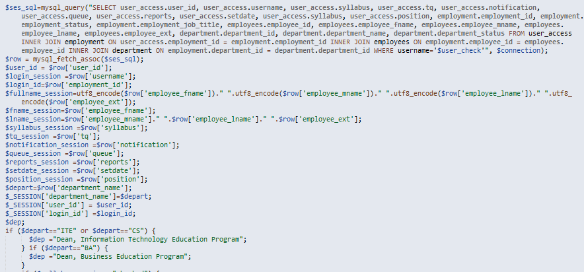In transforming all the collected required function of the user for the proposed system proponents created the entire necessary module indicated below with the help of the tools and technologies stated above.

*Figure 9 user Profile Code Snippet*

The figure show the source code in creating the user profile for the display of personal data associated with a particular user.

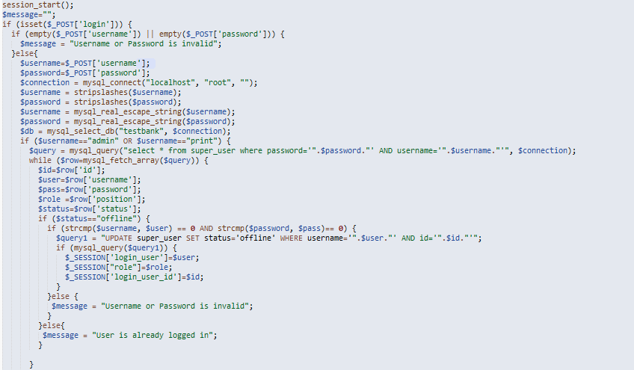45

*Figure 10 Log-in Code Snippet*

The figure shows the source code of the log-in page where in the user provide their system username and password in order to have access to the proposed system.

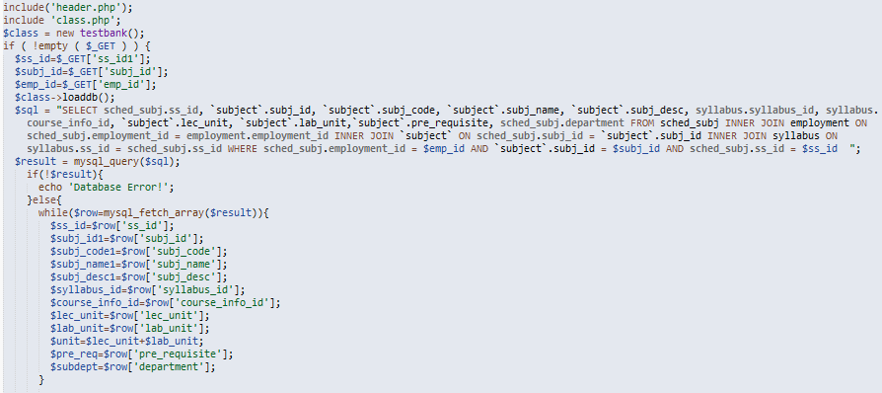46

*Figure 11 Syllabus Code Snippet*

The figure shows the source code of the syllabus creation where topics of every day subject is inputted in a week per faculty.

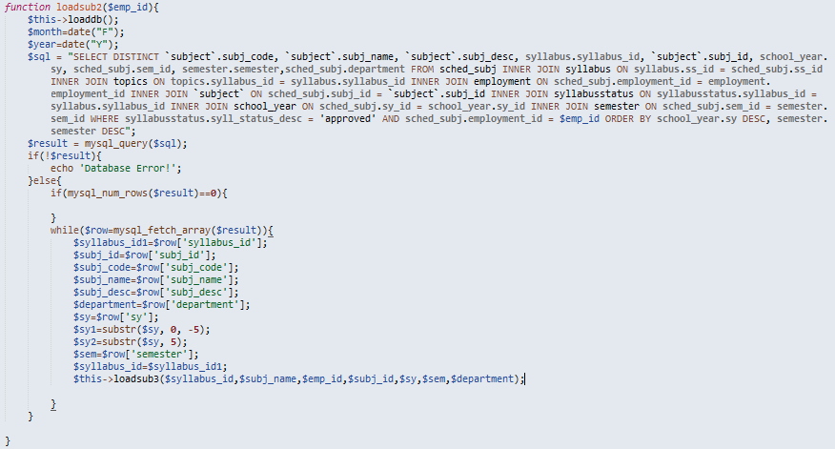47

*Figure 12 Test Questionnaire and Table of Specification*

Creation Code Snippet

The figure shows the codes for the creation of test questionnaires, questions created and identified under what Bloom’s Taxonomy Cognitive level it belongs will be saved automatically to the system group by subject.

48

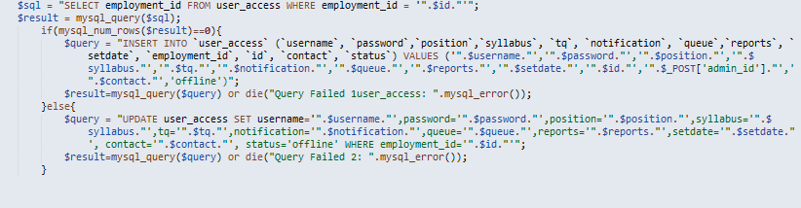

*Figure 13 User Security and Accessibility*

The figure displays the user accessibility, the grants that would be available to them based on their current position in ACLC.

49

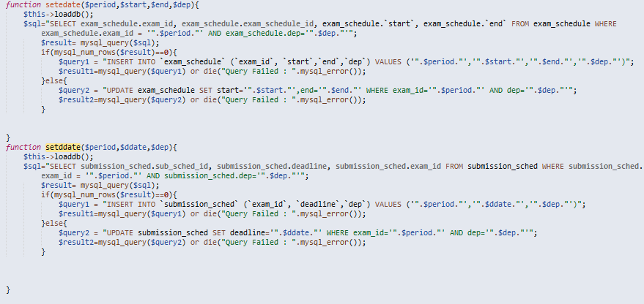

*Figure 14 Setting of Exam Schedule*

The figure portrays the source code for setting of exam schedule which will be the basis for the submission reports module where the program head and the department dean can monitor the submission of the faculty.

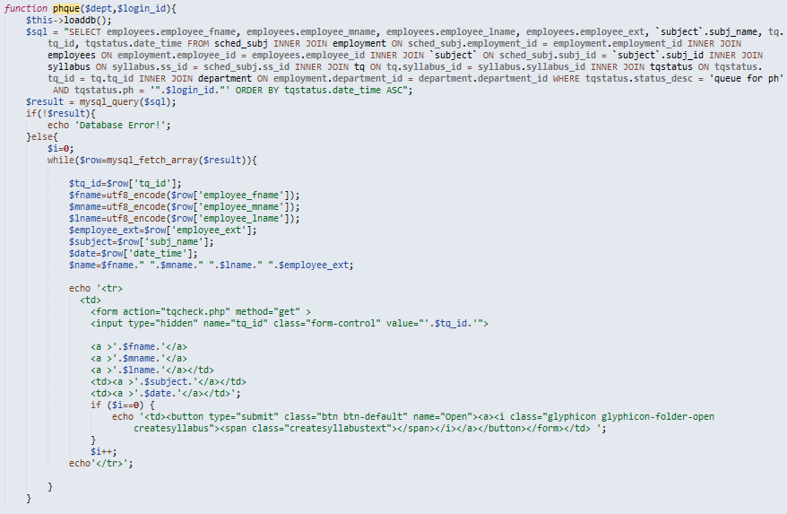50

*Figure 15 Queuing of TQ and TOS Program Head*

This figure shows the code for the queuing of test questionnaires and table of specifications for the program head where the program head can view the submitted TQ and TOS by the instructors for checking.

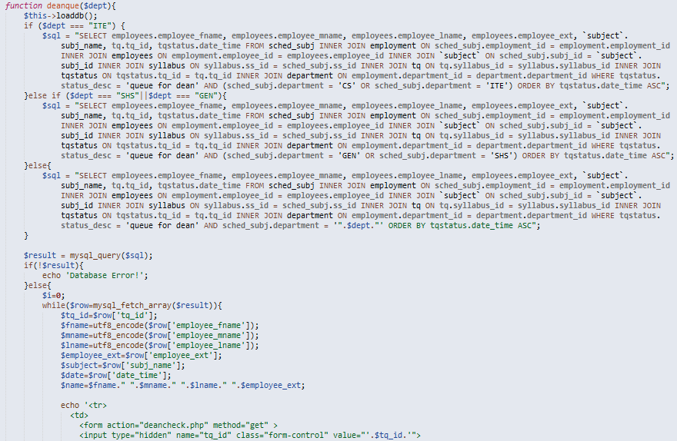51

*Figure 16 Queuing of TQ and TOS Dean View*

The figure displays the code for the questionnaires and table of specifications for the Dean where the Dean can view the checked TQ and TOS by the program head for re-checking.

52

**4.4 Usability, Reliability and Validity Test**

The proponents used System Usability Scale (SUS) that provides a “quick and dirty”, reliable tool for measuring the usability. It consists of a 10 item questionnaire with five response options for respondents; from strongly agree to strongly disagree. It allows respondents to evaluate a wide variety of products and services, including hardware, software, mobile devices, websites and applications.  
 The SUS is a 10 item questionnaire with 5 response options.

1. I think that I would like to use this system frequently.
2. I found the system is unnecessarily complex.
3. I thought the system was easy to use.
4. I think that I would need the support of a technical person to be able to use this system.
5. I found the various functions in this system were well integrated.
6. I found the various functions in this system where there was too much inconsistency in this system.
7. I would imagine that most people would learn to use this system very quickly.
8. I found the system very cumbersome to use.
9. I felt very confident using the system.
10. I needed to learn a lot of things before I could get going with this system.

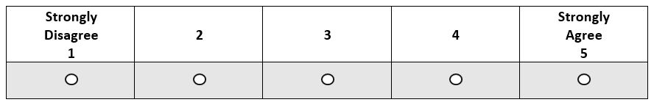53

*Figure 17 Response format of System Usability Scale Test*

**4.5 System Usability Scale Test Result**

After conducting the survey which the proponents used SUS Machine, the gathered ratings from the 10 respondents were calculated using SUS Calculator. The proponents come up to the result of 82.5 as maximum score, 57.5 as minimum, 68.5 as mean or the average score and 685 as total score. Since the mean result is 68.5, it is considered above average.

54

*Table 14 Descriptive Statistics of SUS*

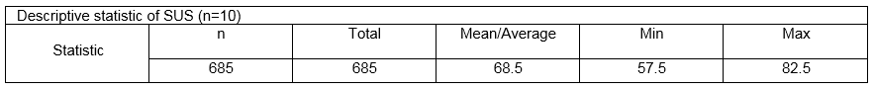

CHAPTER 5

**SUMMARY, CONCLUSIONS AND RECOMMENDATIONS**

**5.1 Summary of Findings**

To encapsulate the purpose of this project was to create a storage of test questionnaires for retrieval purposes of test questions in order to reduce papers usage in creating, checking, and revising test questionnaires. To accomplish the project researchers underwent research, observation, interview, and surveys to the respondents which were the instructors, program heads, deans, printing in-charge and the admin, for the researchers to know the flow of the processes, the things that are needed to be applied, considered and to be followed such as using the Standard Program Graduate Outcome and the intended Learning Outcome given by the CHED. Aligning TOS and TQ by following the 30% by 70% computation of the division of cognitive domain levels by Bloom's Taxonomy.

Following the project's objective after gathering data for the user and systems requirement, the project's queries and functions were developed. After developing the project ACLC Test Bank, the researchers conducted testing and surveys with a total of 10 respondents composed of the ACLC faculty, program head, and dean using System Usability Scale (SUS) test. SUS test is a reliable tool for

**56**

Measuring the system usability. It consists of a 10 item questionnaire with 5 response options from strongly agree to strongly disagree. The researchers used SUS calculator and came up with a result of 82.5 as maximum score, 57.5 as minimum and 68.5 as mean or the average score and 685 as total score. Since the mean result is 68.5, it is considered above average which concludes that the respondents find the proposed system usable.  
 During the testing, there are some suggestions that the proponents consider as recommendation for the next researcher such as the system can auto detect what type of cognitive level that the question belongs to and having an online version of ACLC Test Bank.

57

**5.2 Conclusions**

The study introduces ACLC Test Bank with less usage of papers and more reliable process in such a way that it has security measures, it can be accessible anytime and anywhere inside the school premises. And it improves the productivity of the faculty. Also, this system will be beneficial in a way of maximizing the faculty’s time and effort and company’s resources. With the use of this system creating TQ, TOS and Syllabi, submitting TQ, checking of TQ and TOS to program head and dean will be more efficient in such a way that the TQ and TOS will automatically queue to the program head and dean page upon submission of the instructor.

As we are on the testing phase of developing the ACLC Test Bank System based on the survey conducted with ACLC faculty, program head and dean as the respondents, the proposed system met their specific task. The success of ACLC Test Bank required high level of commitment from the company’s management and its employees.

58

**5.3 Recommendations**

In future work, researcher suggested that the system needs an Artificial Intelligence System support that has an automatic decision upon filtering cognitive domain level in every question to fulfill more of the user’s preferences. And an online version of ACLC Test Bank, for the user to access the system anytime anywhere.

59

**BIBLIOGRAPHY**

Anderson, J. (1999). *Internet Test-making Method.* United States Patent Anderson et al.

Roizen, M. (1987). *Portable System for Choosing Pre-operative Patient Test.* United States Patent Roizen et al.

Minaei-Bidgoli, B. (2004). *Data Mining for a Web-Based Educational System.* Michigan State University.

Khan, L. and Thuraisingham, B. (2005). *Data Mining Applications in Biometrics System*. The University of Texas at Dallas.

60-71

**APPENDICES**

72

**D. Tables**

**User Requirements**

|  |  |  |  |  |  |
| --- | --- | --- | --- | --- | --- |
| **Name of Project** | **User** | **Main Module** | **Sub Module 1** | **Sub Module 2** | **Sub Module 3** |
| ACLC Test Bank | Instructor, Program Head, Dean, and Printing in-charge | User Profile | Instructor Registration |  |  |
|  | Program Head Registration |  |  |
|  | Dean Registration |  |  |
|  | Printing in-charge Registration |  |  |
|  | Super User | Password and username Setting of the Users |  |

73

|  |  |  |  |  |  |
| --- | --- | --- | --- | --- | --- |
| **Name of Project** | **User** | **Main Module** | **Sub module 1** | **Sub module 2** | **Sub module 3** |
|  |  |  |  | Setting of users |  |
|  |  | Log-IN | Instructor | Restrictions |  |
|  |  |  | Program Head | Restrictions |  |
|  |  |  | Dean | Restrictions |  |
|  |  |  | Printing In-charge | Restrictions |  |
|  |  | Syllabus | Subject Lists/ Subject Loaded | Syllabus Template (Based on department( |  |

74

|  |  |  |  |  |  |
| --- | --- | --- | --- | --- | --- |
| **Name of Project** | **User** | **Main Module** | **Sub module 1** | **Sub module 2** | **Sub module 3** |
|  |  | SUBJECT LISTS | TQ | List Types of Question | Order/Sequence types of Questions |
|  |  |  |  | Cognitive Level(Bloom’s) |  |
|  |  |  |  | Remarks |  |
|  |  |  |  | Points |  |
|  |  |  | TOS | Subject Topics |  |
|  |  |  |  | Cognitive Levels |  |

75

|  |  |  |  |  |  |
| --- | --- | --- | --- | --- | --- |
| **Name of Project** | **User** | **Main Module** | **Sub module 1** | **Sub module 2** | **Sub module 3** |
|  |  |  |  | Remarks |  |
|  |  | Security | User Account |  |  |
|  |  |  | Accessibility |  |  |
|  |  | SET EXAM SCHEDULE | Exam Schedule |  |  |
|  |  |  | Deadline of Submission of TQ & TOS |  |  |
|  |  | Queuing | TOS Queuing (Program Head/Dean) |  |  |

76

|  |  |  |  |  |  |
| --- | --- | --- | --- | --- | --- |
| **Name of Project** | **User** | **Main Module** | **Sub module 1** | **Sub module 2** | **Sub module 3** |
|  |  |  | TQ Queuing Final Printing (Ma’am Jinky) |  |  |
|  |  |  |  | SMS Notification |  |
|  |  | Notification |  |  |  |
|  |  |  | Instructor |  |  |
|  |  |  | Rejected TQ List | Instructor’s Name – Subject Lists |  |
|  |  |  |  |  |  |

77

|  |  |  |  |  |  |
| --- | --- | --- | --- | --- | --- |
| **Name of Project** | **User** | **Main Module** | **Sub module 1** | **Sub module 2** | **Sub module 3** |
|  |  |  | Rejected TOS Lists | Instructor’s Name – Subject Lists |  |
|  |  |  | Printed TQ Lists | Instructor’s Name – Subject Lists |  |
|  |  |  | Pending TQ Lists | Instructor’s Name – Subject Lists |  |

78

|  |  |  |  |  |  |
| --- | --- | --- | --- | --- | --- |
| **Name of Project** | **User** | **Main Module** | **Sub module 1** | **Sub module 2** | **Sub module 3** |
|  |  |  | Pending TOS Summary | Instructor’s Name – Subject Lists |  |
|  |  |  | Late Submission | Instructor’s Name – Subject Lists |  |

79

**Scope Meet Point**

|  |  |  |  |  |
| --- | --- | --- | --- | --- |
| **Main Module** | **Sub module 1** | **Sub module 2** | **Sub module 3** | **Scope** |
| User Profile | Instructor Registration |  |  | *Dependent to Curriculum  *HRMS (employee Information |
|  | Program Head Registration |  |  |
|  | Dean Registration |  |  |
|  | Printing In-charge Registration |  |  |

**80**

|  |  |  |  |  |
| --- | --- | --- | --- | --- |
| **Main Module** | **Sub module 1** | **Sub module 2** | **Sub module 3** | **Scope** |
|  |  | Setting of Users |  |  |
| Log-in | Instructor | Restrictions |  |  |
|  | Program Head | Restrictions |  |  |
|  | Dean |  |  |  |
|  | Printing in-charge | Restrictions |  |  |

**81**

|  |  |  |  |  |
| --- | --- | --- | --- | --- |
| **Main Module** | **Sub module 1** | **Sub module 2** | **Sub module 3** | **Scope** |
| Syllabus | Subject Lists / Subject Loaded | Syllabus Template(Based of department) |  | Includes the Syllabus |
| SUBJECT LISTS | TQ | List Types of Question | Order/Sequence Types of Questions | An add test questionnaire with the approval of the Dean. Can print test questionnaire.  Create a test questionnaire/  Can classify of each question based on the table of Specification (Bloom’s Taxonomy) |
|  |  | Cognitive Level (Bloom’s) |  |

**82**

|  |  |  |  |  |
| --- | --- | --- | --- | --- |
| **Main Module** | **Sub module 1** | **Sub module 2** | **Sub module 3** | **Scope** |
|  |  | Points |  | *Can Classify each question based on the subject and topic indicated in the syllabus  * Sort the data according to subjects, semester and school year. |

**83**

|  |  |  |  |  |
| --- | --- | --- | --- | --- |
| **Main Module** | **Sub module 1** | **Sub module 2** | **Sub module 3** | **Scope** |
|  |  |  |  | Queuing of the TQ for printing  *queuing of the TQ and TOS for checking  *auto computation of the percentage – 70% high level, 30% low level  *Cannot submit test questionnaire if the computation of percentage wasn’t met. |

**84**

|  |  |  |  |  |
| --- | --- | --- | --- | --- |
| **Main Module** | **Sub module 1** | **Sub module 2** | **Sub module 3** | **Scope** |
| Security | User Account |  |  |  |
|  | Accessibility |  |  |  |
| SET EXAM SCHEDULE | Exam Schedule |  |  | *Setting exam schedule. The system must display the deadline of submission of TQ and TOS  *Note: If the instructor did not submit on time his/her TQ will be considered as Late Submission |

**85**

|  |  |  |  |  |
| --- | --- | --- | --- | --- |
| **Main Module** | **Sub module 1** | **Sub module 2** | **Sub module 3** | **Scope** |
| Queuing | TOS Queuing(Program Head/Dean) | Points |  | *Status of approval of the table of specification |

**86**

|  |  |  |  |  |
| --- | --- | --- | --- | --- |
| **Main Module** | **Sub module 1** | **Sub module 2** | **Sub module 3** | **Scope** |
|  | TQ Queuing Final Printing |  |  | *Connected to the user for the printing of questionnaire chech whether the TOS of the questionnaire has already been approved.  *Queuing of the TQ for printing  Queuing of the TQ and TOS for Checking  *Auto computation of the Percentage level |

**87**

|  |  |  |  |  |
| --- | --- | --- | --- | --- |
| **Main Module** | **Sub module 1** | **Sub module 2** | **Sub module 3** | **Scope** |
|  |  |  |  | *Cannot submit test questionnaire if the computation of the percentage wasn’t met  *Submission Hierarchy must be followed   1. Instructor 2. Program head 3. Dean 4. Printing (Ma’am Jinky) |
|  |  |  | SMS NOTIFICATION |  |

**88**

|  |  |  |  |  |
| --- | --- | --- | --- | --- |
| **Main Module** | **Sub module 1** | **Sub module 2** | **Sub module 3** | **Scope** |
|  |  | Points |  | *Can Classify each question based on the subject and topic indicated in the syllabus  * Sort the data according to subjects, semester and school year. |

**89**

|  |  |  |  |  |
| --- | --- | --- | --- | --- |
| **Main Module** | **Sub module 1** | **Sub module 2** | **Sub module 3** | **Scope** |
|  | PROGRAM HEAD  *Remarks in TQ and TOS |  |  |  |
|  |  | Breakdown History: Count of Submission |  |  |
|  | Dean |  |  |  |

**90**

|  |  |  |  |  |
| --- | --- | --- | --- | --- |
| **Main Module** | **Sub module 1** | **Sub module 2** | **Sub module 3** | **Scope** |
|  |  | TQ and TOS for Checking:  Approved:  Revised |  | *report  *Date of the submission of questionnaire  *Date of approved TOS  *Every submission of a particular subject will be counted and TOS Lists  *Printed TQ  *Pending TQ and TOS  *Late Submission |
| Reports | Approved TQ Lists | *Instructor’s Name  *Subject Lists |  |
|  | Approved TOS Lists | *Instructor’s Name  *Subject Lists |  |
|  | Rejected TQ Lists | *Instructor’s name  *Subject lists |  |

**91**

|  |  |  |  |  |
| --- | --- | --- | --- | --- |
| **Main Module** | **Sub module 1** | **Sub module 2** | **Sub module 3** | **Scope** |
|  | Printed TQ Lists | *Instructor’s Name  *Subject Lists |  |  |
|  | Pending TQ | *Instructor’s Name  *Subject Lists |  |  |
|  | Pending TOS Summary | *Instructor’s Name  *Subject Lists |  |  |
|  | Late Submission | *Instructor’s Name  *Subject Lists |  |  |

**92**

**Sc**

|  |  |  |  |  |
| --- | --- | --- | --- | --- |
| **Main Module** | **Sub module 1** | **Sub module 2** | **Sub module 3** | **Scope** |
| User Profile | Instructor Registration |  |  | *Dependent to curriculum  *HRMS (Employee Information) |
|  | Program Head Registration |  |  |
|  | Dean Registration |  |  |
|  | Printing In-Charge Registration |  |  |

**93**

|  |  |  |  |  |
| --- | --- | --- | --- | --- |
| **Main Module** | **Sub module 1** | **Sub module 2** | **Sub module 3** | **Scope** |
|  |  | Setting of Users |  |  |
| Log-in | Instructor | Restrictions |  |  |
|  | Program Head | Restrictions |  |  |
|  | Dean | Restrictions |  |  |
|  | Printing in-charge | Restrictions |  |  |

**94**

|  |  |  |  |  |
| --- | --- | --- | --- | --- |
| **Main Module** | **Sub module 1** | **Sub module 2** | **Sub module 3** | **Scope** |
| Syllabus | Subject Lists/Subject Loaded | Syllabus Template (Based on department) |  | Includes the Syllabus |
| SUBJECT LISTS | TQ | List Types of Questions | Order/Sequence Type of Question | Can add test Questionnaire with the approval of the Dean  Can print test questionnaire  Create a Test questionnaire  Can classify of each question based on the table of specification (Bloom’s Taxonomy) |
|  |  | Cognitive Level (Bloom’s) |  |

**95**

|  |  |  |  |  |
| --- | --- | --- | --- | --- |
| **Main Module** | **Sub module 1** | **Sub module 2** | **Sub module 3** | **Scope** |
|  |  | Points |  | *Can classify each question based on the subject and topic indicated in the syllabus  *Sort the data according to subjects, semester and school year. |
|  | TOS | Subject Topics |  | *Status of the approval of the table of specification  *Connected to the user for the printing of questionnaire, check whether the TOS of the questionnaire has already been approved. |
|  |  | Cognitive Levels |  |
|  |  | Remarks |  |

**96**

|  |  |  |  |  |
| --- | --- | --- | --- | --- |
| **Main Module** | **Sub module 1** | **Sub module 2** | **Sub module 3** | **Scope** |
|  |  |  |  | Queuing of the TQ for printing  *queuing of the TQ and TOS for Checking  *auto computation of percentage – 70% High level, 30% Low level  *Cannot submit test questionnaire if the computation of the percentage wasn’t met. |

**97**

|  |  |  |  |  |
| --- | --- | --- | --- | --- |
| **Main Module** | **Sub module 1** | **Sub module 2** | **Sub module 3** | **Scope** |
| Security | User Account |  |  |  |
|  | Accessibility |  |  |  |
| SET EXAM SCHEDULE | Exam Schedule |  |  | *Setting exam Schedule  The system must display the deadline of submission of the TQ and TOS  *Note: If the Instructor did not submit on time his/her TQ will be considered as Late Submission |

**98**

|  |  |  |  |  |
| --- | --- | --- | --- | --- |
| **Main Module** | **Sub module 1** | **Sub module 2** | **Sub module 3** | **Scope** |
| Queuing | TOS Queuing (Program Head/Dean) |  |  | *Status of the approval of the table of specification |

**99**

|  |  |  |  |  |
| --- | --- | --- | --- | --- |
| **Main Module** | **Sub module 1** | **Sub module 2** | **Sub module 3** | **Scope** |
|  | TQ Queuing Final Printing (Ma’am Jinky) |  |  | *Connected to the user for the printing of questionnaire check whether the TOS of the questionnaire has already been approved.  *Queuing of TQ for printing.  *Queuing of the TQ and TOS for Checking.  *Auto Computation of the percentage – 70% High Level, 30% Low level |

**100**

|  |  |  |  |  |
| --- | --- | --- | --- | --- |
| **Main Module** | **Sub module 1** | **Sub module 2** | **Sub module 3** | **Scope** |
|  |  |  |  | *Cannot submit test questionnaire if the computation of the percentage wasn’t met  *Submission Hierarchy must be followed   1. Instructor 2. Program Head 3. Dean 4. Printing (Ma’am Jinky) |
|  | SMS NOTIFICATION |  |  |  |

**101**

|  |  |  |  |  |
| --- | --- | --- | --- | --- |
| **Main Module** | **Sub module 1** | **Sub module 2** | **Sub module 3** | **Scope** |
| Notification |  |  |  |  |
|  | Instructor |  |  | *Notification  *Automatic notify in the instructor portal what is the status of the Test Question if revised or approved  *Send SMS to the Instructor TQ and TOS is approved |
|  |  | Approved and for Revision TQ Count |  |
|  |  |  | Specification for Approved and Disapproved |

**102**

|  |  |  |  |  |
| --- | --- | --- | --- | --- |
| **Main Module** | **Sub module 1** | **Sub module 2** | **Sub module 3** | **Scope** |
| Notification |  |  |  |  |
|  | Instructor |  |  | *Notification  *Automatic notify in the instructor portal what is the status of the Test Question if revised or approved  *Send SMS to the Instructor TQ and TOS is approved |
|  |  | Approved and for Revision TQ Count |  |
|  |  |  | Specification for Approved and Disapproved |

**103**

|  |  |  |  |  |
| --- | --- | --- | --- | --- |
| **Main Module** | **Sub module 1** | **Sub module 2** | **Sub module 3** | **Scope** |
|  |  | TQ and TOS for Checking:  Approved:  Revised: |  | * Report * Date of the submission of the Questionnaire * Date of approved TOS * Every submission of a particular subject will be counted. * Name of instructor who submitted TQ and TOS per subject * Rejected TQ and TOS Lists * Printed TQ * Pending TQ and TOS * Late Submission |
| Reports | Approved TQ Lists | *Instructor’s Name  *Subject Lists |  |
|  | Approved TOS Lists | *Instructor’s Name  *Subject Lists |  |
|  | Rejected TQ Lists | *Instructor’s Name  *Subject Lists |  |

**104**

|  |  |  |  |  |
| --- | --- | --- | --- | --- |
| **Main Module** | **Sub module 1** | **Sub module 2** | **Sub module 3** | **Scope** |
|  | Printed TQ Lists | *Instructor’s Name  *Subject Lists |  |  |
|  | Pending TQ | *Instructor’s Name  *Subject Lists |  |  |
|  | Pending TOS Summary | *Instructor’s Name  *Subject Lists |  |  |
|  | Late Submission | *Instructor’s Name  *Subject Lists |  |  |